* Copyright for test papers and marking guides remains with *West Australian Test Papers*.
* The papers may only be reproduced within the purchasing school according to the advertised conditions of sale.
* Test papers must be withdrawn after use and stored securely in the school until **Friday 12th June 2020**

**HUMAN BIOLOGY**

**Unit 3**

**2020**

**Marking Key**

**Insert School Logo**

Name: _______________________________________________________

Teacher: ___________________________________________________

**Time allowed for this paper**

Reading time before commencing work: ten minutes

Working time for the paper: three hours

**Materials required/recommended for this paper**

***To be provided by the supervisor***

This Question/Answer Booklet

Multiple-choice Answer Sheet

***To be provided by the candidate***

Standard items: pens (blue/black preferred), pencils (including coloured), sharpener, correction fluid/tape, eraser, ruler, highlighters

Special items: non-programmable calculators approved for use in this examination

**Important note to candidates**

No other items may be taken into the examination room. It is **your** responsibility to ensure that you do not have any unauthorised material. If you have any unauthorised material with you, hand it to the supervisor **before** reading any further.

**Structure of this paper**

|  |  |  |  |  |  |
| --- | --- | --- | --- | --- | --- |
| Section | Number of questions available | Number of questions to be answered | Suggested working time (minutes) | Marks available | Percentage of examination |
| Section One  Multiple-choice | 30 | 30 | 40 | 30 | 30 |
| Section Two  Short answers | 8 | 8 | 90 | 100 | 50 |
| Section Three  Extended answers | 3 | 2 | 50 | 40 | 20 |
|  |  |  |  | **Total** | 100 |

**Instructions to candidates**

1. The rules for the conduct of the Western Australian examinations are detailed in the *Year 12 Information Handbook 2020*. Sitting this examination implies that you agree to abide by these rules.

2. Write your answers in this Question/Answer booklet preferably using a blue/black pen. Do not use erasable or gel pens.

3. Answer the questions according to the following instructions.

Section One: Answer all questions on the separate Multiple-choice answer sheet provided. For each question, shade the box to indicate your answer. Use only a blue or black pen to shade the boxes. Do not use erasable or gel pens. If you make a mistake, place a cross through that square, then shade your new answer. Do not erase or use correction fluid/tape. Marks will not be deducted for incorrect answers. No marks will be given if more than one answer is completed for any question.

Section Two: Write your answers in this Question/Answer booklet. Wherever possible, confine your answers to the line spaces provided.

Section Three: Consists of three questions. You must answer two questions. Tick the box next to the question you are answering. Write your answers in this Question/Answer booklet.

4. You must be careful to confine your answers to the specific questions asked and to follow any instructions that are specific to a particular question.

5. Supplementary pages for planning/continuing your answers to questions are provided at the end of this Question/Answer booklet. If you use these pages to continue an answer, indicate at the original answer where the answer is continued, i.e. give the page number.

**Section One: Multiple-choice 30% (30 Marks)**

This section has **30** questions. Answer all questions on the separate Multiple-choice answer sheet provided. For each question shade the box to indicate your answer. Use only a blue or black pen to shade the boxes. Do not use erasable or gel pens. If you make a mistake, place a cross through that square, then shade your new answer. Do not erase or use correction fluid/tape. Marks will not be deducted for incorrect answers. No marks will be given if more than one answer is completed for any question.

Suggested working time: 40 minutes.

|  |  |
| --- | --- |
| Question | Answer |
| 1 | A |
| 2 | B |
| 3 | B |
| 4 | D |
| 5 | A |
| 6 | A |
| 7 | C |
| 8 | A |
| 9 | C |
| 10 | B |
| 11 | C |
| 12 | D |
| 13 | D |
| 14 | D |
| 15 | D |
| 16 | A |
| 17 | B |
| 18 | B |
| 19 | C |
| 20 | C |
| 21 | C |
| 22 | D |
| 23 | B |
| 24 | C |
| 25 | D |
| 26 | D |
| 27 | A |
| 28 | B |
| 29 | B |
| 30 | D |

1. Which of the following is an example of artificial active immunity?
   1. vaccinations
   2. being injected with antibodies
   3. contracting the disease
   4. antibodies passed through the placenta
2. Osmotic pressure is determined by osmoreceptors. Where in the body would you find osmoreceptors?
   1. Medulla oblongata
   2. hypothalamus
   3. anterior pituitary
   4. the skin
3. The descending tracts contained in the white matter of the spinal cord
   1. carry sensory information to the brain.
   2. conduct nerve impulses down the spinal cord to lower motor neurons.
   3. contain motor axons to carry nerve impulses away from the peripheral nervous system.
   4. carry sensory information away from the brain.
4. Which of the following is an **accurate** comparison of lipid-soluble and water-soluble hormones?
   1. water-soluble hormones are long acting and lipid-soluble hormones are short acting
   2. water-soluble hormones do not require a secondary messenger and lipid-soluble hormones do
   3. water-soluble hormones include cortisol and lipid-soluble hormones include insulin
   4. water-soluble hormones bind to receptors on the cell membrane and lipid-soluble hormones diffuse through the cell membrane
5. A Human Biology student was doing an experiment to measure to what extent energy drinks improve physical performance. Her hypothesis was ‘If a student consumes a can of energy drink immediately before running 100m they will record a faster time than without consuming the energy drink’. The student made sure to repeat her experiment three times for each participant. She did this to ensure the experiment was
   1. reliable.
   2. valid.
   3. accurate.
   4. controllable.
6. The part of the brain responsible for the autonomic regulation of hydrogen ion concentration is the
   1. medulla oblongata.
   2. hypothalamus.
   3. cerebrum.
   4. cerebellum.
7. Which endocrine organ produces growth hormone (GH) and adrenocorticotrophic hormone (ACTH)?
   1. ovaries
   2. adrenal cortex
   3. anterior pituitary
   4. pancreas
8. A person suffering from weight gain, fatigue and lack of tolerance to cold has been prescribed medication from their doctor. They are **most** likely to be suffering from
   1. hypothyroidism.
   2. hyperthyroidism.
   3. type I diabetes.
   4. type II diabetes
9. Which of the following would be a **correct** definition of negative feedback?
   1. when the body returns to normal
   2. when the original stimulus is intensified
   3. when the original stimulus is reversed
   4. when the original stimulus cannot be reversed

Questions 10 -12 refer to the diagram below.

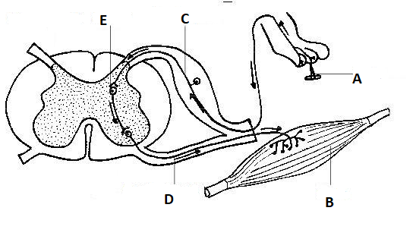

1. The structure labelled ‘D’ could be described as
   1. a sensory neuron carrying information towards form the stimulus to the CNS.
   2. a motor neuron carrying information to the effector.
   3. an interneuron transferring information from the sensory neuron to the motor neuron.
   4. a muscle fibre receiving an impulse and carrying out an effect.
2. The structure labelled ‘E’ could be described as
   1. a sensory neuron carrying information towards form the stimulus to the CNS.
   2. a motor neuron carrying information to the effector.
   3. an interneuron transferring information from the sensory neuron to the motor neuron.
   4. a muscle fibre receiving an impulse and carrying out an effect.
3. What type of stimulus receptor would be found at ‘A’?
   1. thermoreceptor
   2. chemoreceptor
   3. osmoreceptor
   4. pain receptor

Question 13 refers to the diagram below.

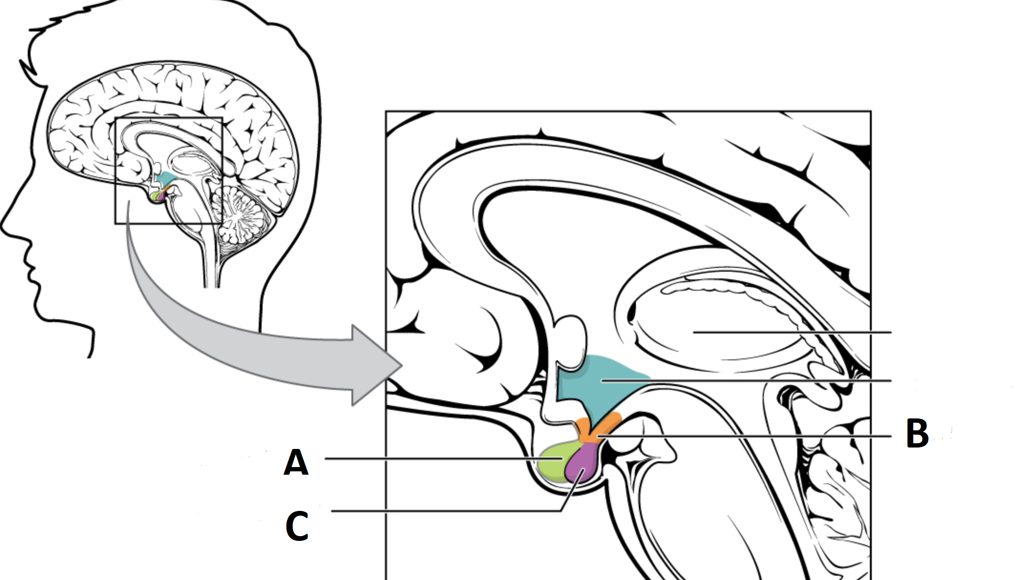

1. Which of the following are labelled **correctly**?
   1. A= Infundibulum, B= Anterior Pituitary, C= Posterior Pituitary
   2. A= Anterior Pituitary, B= Hypothalamus, C= Posterior Pituitary
   3. A= Posterior Pituitary, B= Hypothalamus, C= Anterior Pituitary
   4. A= Anterior Pituitary, B= Infundibulum, C= Posterior Pituitary
2. Which of the following is a **correct** description of the relationship between the hypothalamus and pituitary gland?
   1. the hypothalamus is connected to the posterior pituitary and anterior pituitary via blood vessels
   2. the hypothalamus is connected to the posterior pituitary via blood vessels and anterior pituitary via nerve fibres
   3. the hypothalamus is connected to the posterior pituitary and anterior pituitary via nerve fibres
   4. the hypothalamus is connected to the posterior pituitary via nerve fibres and anterior pituitary via blood vessels
3. A disease has been discovered on the south coast of Western Australia. The disease causes people infected to have high fevers and hallucinations. The outbreak began when sufferers consumed infected food from a single petrol station. The mode of transmission for this pathogen is likely to be
   1. direct and indirect contact
   2. transfer of body fluids
   3. disease specific vectors
   4. contaminated food and water
4. On hot days, human beings lose a lot of fluid through sweat. This loss of water causes changes in the nephron to minimise the impact of sweating. Which of the following **best** describes this response?
   1. ADH is released by the posterior pituitary causing an increase in the permeability of the collecting duct
   2. ADH is released by the posterior pituitary causing a decrease in the permeability of the collecting duct
   3. ADH is released by the adrenal medulla to increase basal cell metabolism
   4. ADH is released by the adrenal medulla to decrease basal cell metabolism

Question 17 and 18 refer to the image shown below.

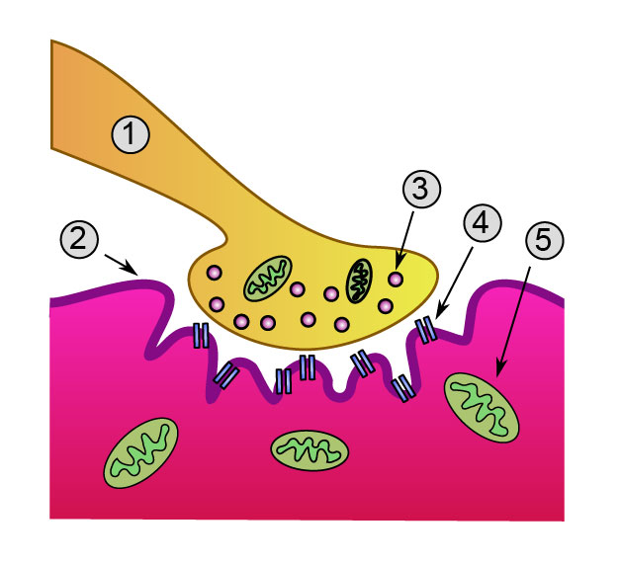

1. In the diagram where are the neurotransmitters located prior to nervous transmission?
   1. 2
   2. 3
   3. 4
   4. 5
2. What is the name of the structure labelled 4?
   1. mitochondrion
   2. receptor protein
   3. synapse
   4. axon terminal
3. Which of the following pairings of hormone and target organ is **incorrect**?
   1. hormone: follicle stimulating hormone (FSH); target organ: ovary
   2. hormone: glucagon; target organ: liver and fat
   3. hormone: parathyroid hormone; target organ: uterus
   4. hormone: oxytocin; target organ: uterus
4. Which is the **best** definition for an antibody?
   1. any substance capable of causing a specific immune response
   2. any organism that causes disease
   3. a substance produced in B-lymphocytes that stops bacterial proliferation
   4. a substance that is used in all vaccines
5. Which of the following describes the **correct** definition of agglutination by antibody action?
   1. make soluble substances insoluble
   2. coat pathogens so they can be consumed by phagocytes
   3. cause particles including the pathogen to clump together
   4. inhibit reactions of pathogens
6. The part of the brain most associated with the autonomic thirst reflex is?
   1. medulla
   2. cerebrum
   3. cerebellum
   4. hypothalamus
7. For which of the following sets of data is a line graph **not** suitable?
   1. the average heart rate of a student before, during and after exercise
   2. the number of grandchildren of residents in a nursing home
   3. the total kilojoules consumed per day of an athlete
   4. the time taken for an enzyme to fully breakdown its substrate at different temperatures
8. Which of the following is **correct** in relation to the sympathetic and parasympathetic divisions of the autonomic nervous system?

|  |  |  |
| --- | --- | --- |
|  | **Sympathetic Division** | **Parasympathetic Division** |
| (a) | causes an increase in sweating | causes a decrease in sweating |
| (b) | pupils constrict | pupils dilate |
| (c) | blood flow to skeletal muscles increases | blood flow to internal organs increases |
| (d) | heart rate decreases | heart rate increases |

1. Which of the following is the name of cells that are part of the immune system that slow down the immune response when the pathogen has been eliminated?
   1. killer T-cells
   2. helper T-cells
   3. Memory cells
   4. suppressor T-cells
2. A person with Hashimoto’s disease was in a medical trial where they had to record the levels of thyroxine in their blood every morning before breakfast for 5 days. The results are

|  |  |  |  |  |  |
| --- | --- | --- | --- | --- | --- |
| Day | 1 | 2 | 3 | 4 | 5 |
| Thyroxine level (ng/dL) | 2.9 | 3.2 | 4.1 | 2.9 | 5.4 |

Calculate the mean blood level of thyroxine over the 5 days.

* 1. 2.9 ng/dL
  2. 3.2 ng/dL
  3. 2.7 ng/dL
  4. 3.7 ng/dL

1. Which of the following is the **best** definition of hormone action by ‘enzyme amplification’?
   1. the effect a hormone has by increasing the total numbers of a particular enzyme
   2. the reduction of activation energy for a chemical reaction to occur
   3. the effect an enzyme has in increasing the rate of reaction
   4. the rate of product formation in an enzyme reaction
2. When a nerve cell is at rest there is a potential difference across the cell membrane of -70mV. This difference in charge is caused by
   1. the membrane continuously pumps positively charged potassium ions from the intracellular fluid to the extracellular fluid.
   2. the intracellular fluid has more negatively charged ions than the extracellular fluid.
   3. the extracellular fluid has more positive sodium ions than the intracellular fluid.
   4. sodium ions which are positively charged are more concentrated in the intracellular fluid.
3. Which of the following comparisons describing the difference in functioning about the nervous system and endocrine system is **correct?**

|  |  |  |
| --- | --- | --- |
|  | **Nervous System** | **Endocrine System** |
| (a) | Slow transmission | Rapid transmission |
| (b) | Short duration | Long lasting |
| (c) | Chemical signals | Electrochemical signals |
| (d) | Many target organs | Single target organs |

1. A researcher was testing the hypothesis:

**“The range of sound frequencies that a person can hear decreases with increasing age”**

She selected a number of subjects, both male and female, of differing ages. A sound generator was used to expose the subjects to sounds of varying frequencies. The dependent variable in this experiment was the:

* 1. age of the subjects.
  2. volume of the sound.
  3. frequency of the sound.
  4. frequency range detected by the subjects.

**Section Two: Short answer 50% (100 Marks)**

This section has **eight** questions. Answer **all** questions. Write your answers in the spaces provided.

Supplementary pages for planning/continuing your answers to questions are provided at the end of this Question/Answer booklet. If you use these pages to continue an answer, indicate at the original answer where the answer is continued, i.e. give the page number.

Suggested working time: 90 minutes.

**Question 31 (13 marks)**

An investigation was carried out to determine the effectiveness of a new medication “hypostop” for the prevention of hypertension in people over the age of 55.

Two groups of people were involved in the investigation who had moderate hypertension. Group 1 was treated with “hypostop” while Group 2 was given a placebo. All participants measured their blood pressure daily for two weeks prior to the trial and for the two weeks during the trial.

The average blood pressure in Group 1 for the two-week trial before starting the medication was 143/95. The average blood pressure for Group 2 over the same period was 147/93. For the two weeks while conducting the experiment Group 1 was 138/88 and Group 2 was 145/95.

1. Propose an appropriate hypothesis for this investigation. (1 mark)

|  |  |
| --- | --- |
| **Description** | **Mark** |
| A statement linking the independent variable to the dependent variable | 1 |
| Eg: The group taking hypostop will show a reduction in average blood pressure compared to the control group/group 2/ those not taking the medication. |  |
| **Total** | **1** |

1. Name the independent and dependent variables in this experiment. (2 marks)

|  |  |
| --- | --- |
| **Description** | **Mark** |
| Independent Variable: Taking Hypostop medication | 1 |
| Dependent: Blood pressure | 1 |
| **Total** | **2** |

1. Why was a placebo used for Group 2 participants? (1 mark)

|  |  |
| --- | --- |
| **Description** | **Mark** |
| Comparison/control group | 1 |
| **Total** | **1** |

1. State **three** variables that would need to be controlled to ensure a fair test.

(3 marks)

|  |  |
| --- | --- |
| **Description** | **Mark** |
| **Any three of the following** | |
| Age/gender | 1-3 |
| Same general health/ previous health history |
| Similar daily exercise |
| Similar diet |
| Same time of day for measuring blood pressure |
| Same method/volume/frequency for administering hypostop (or placebo) |
| **Total** | **3** |

The average blood pressure results for 9 of the Group 1 participants for the two-week medication trial were.

|  |  |  |  |  |  |  |  |  |  |
| --- | --- | --- | --- | --- | --- | --- | --- | --- | --- |
| Participant | 1 | 2 | 3 | 4 | 5 | 6 | 7 | 8 | 9 |
| Average Blood pressure (mmHg)  *systolic  diastolic | 140  90 | 135  85 | 134  82 | 150  100 | 130  80 | 127  80 | 125  85 | 135  85 | 128  90 |

1. State the **median** blood pressure (arranged by systolic pressure). (1 mark)

|  |  |
| --- | --- |
| **Description** | **Mark** |
| 134  82 mmHg | 1 |
| **Total** | **1** |

1. State the **mode** score for this set of data. (1 mark)

|  |  |
| --- | --- |
| **Description** | **Mark** |
| 135  85 mmHg | 1 |
| **Total** | **1** |

1. Suggest which participant could be considered an **outlier.** Explain the reason for your decision? (2 marks)

|  |  |
| --- | --- |
| **Description** | **Mark** |
| Participant 4 | 1 |
| Their blood pressure was significantly higher than the other participants | 1 |
| **Total** | **2** |

1. What conclusion could be drawn based on the results of this study? (2 marks)

|  |  |
| --- | --- |
| **Description** | **Mark** |
| Taking hypostop reduces blood pressure | 1 |
| In people who are aged over 55 | 1 |
| **Total** | **2** |

**Question 32 (16 marks)**

Use the diagram below to answer the following questions.

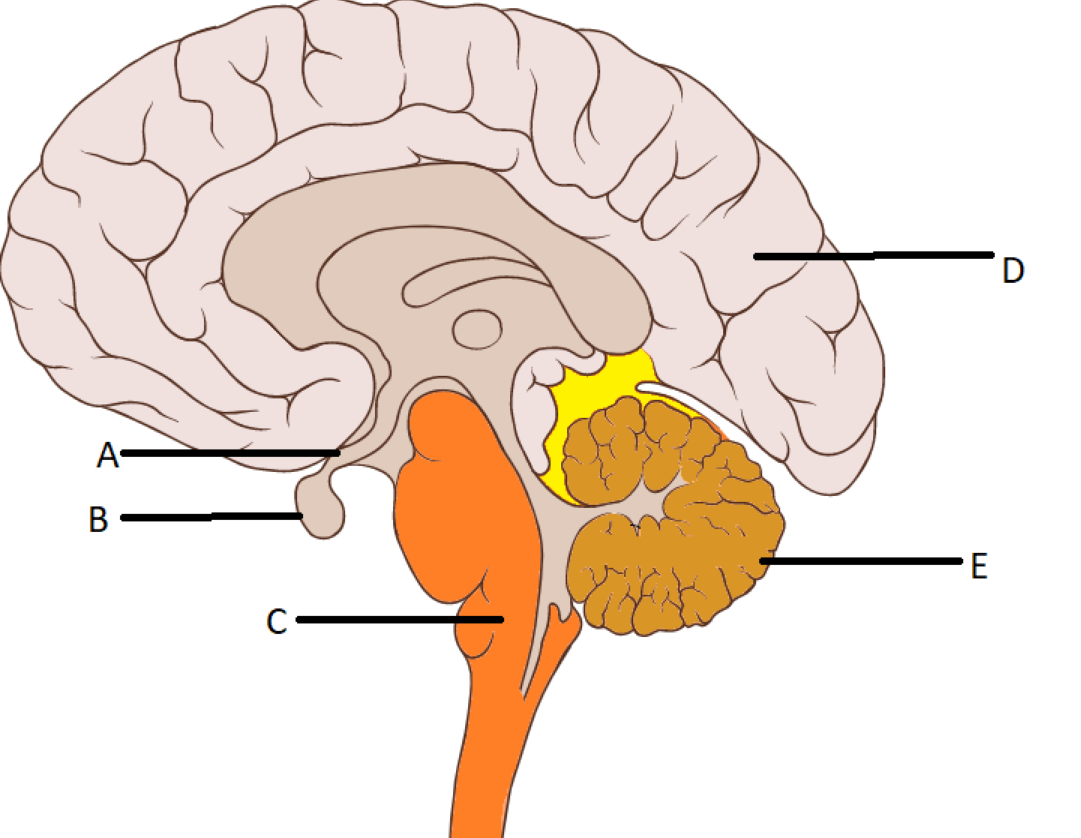

1. Name the following structures. (2 marks)

|  |  |
| --- | --- |
| **Description** | **Mark** |
| A: Infundibulum | 1 |
| B: Pituitary Gland | 1 |
| **Total** | **2** |

1. Describe the function of the following structures. (4 marks)

|  |  |
| --- | --- |
| **Description** | **Mark** |
| C:  Controls (some) autonomic functions of the body  Including the respiratory centre/breathing/blood pressure/ heartrate | 1  1 |
| E:  Coordinates voluntary motor movements  Including posture/balance/coordination/speech/ or results in smooth and balanced motor function | 1  1 |
| **Total** | **4** |

1. D, the cerebrum contains sulci and gyri. What is the difference between these two structures? (2 marks)

|  |  |
| --- | --- |
| **Description** | **Mark** |
| Sulci are downfolds between convolutions in the brain | 1 |
| Gyri are ridges of the brain | 1 |
| **Total** | **2** |

1. Alzheimer’s disease is also associated with dysfunctional autonomic nervous systems. Compare and contrast the somatic and autonomic nervous systems.

(4 marks)

|  |  |  |  |  |  |  |  |  |  |  |  |  |  |  |  |  |  |  |  |  |  |  |  |
| --- | --- | --- | --- | --- | --- | --- | --- | --- | --- | --- | --- | --- | --- | --- | --- | --- | --- | --- | --- | --- | --- | --- | --- |
| |  |  | | --- | --- | | **Description** | **Mark** | | One similarity for 1 mark from the following: |  | | · Acetylcholine used  · Excitatory capabilities  · Receive input from sensory neurons | 1 | | Two differences for 1 mark each from the following rows:     |  |  | | --- | --- | | **Somatic** | **Autonomic** | | Effector: skeletal muscle  Volunatary muscles | Effector: smooth and cardiac muscle and glands  Involuntary miuscles | | Voluntary | Involuntary | | One motor neuron | Two motor neurons | | No use of epinephrine | Use of epinephrine | | No inhibitory capability | Inhibitory capability | | 1-3 | | **Total** | **3** | |  |

**Question 33 (15 marks)**

The diagram below shows the glands of the endocrine system.

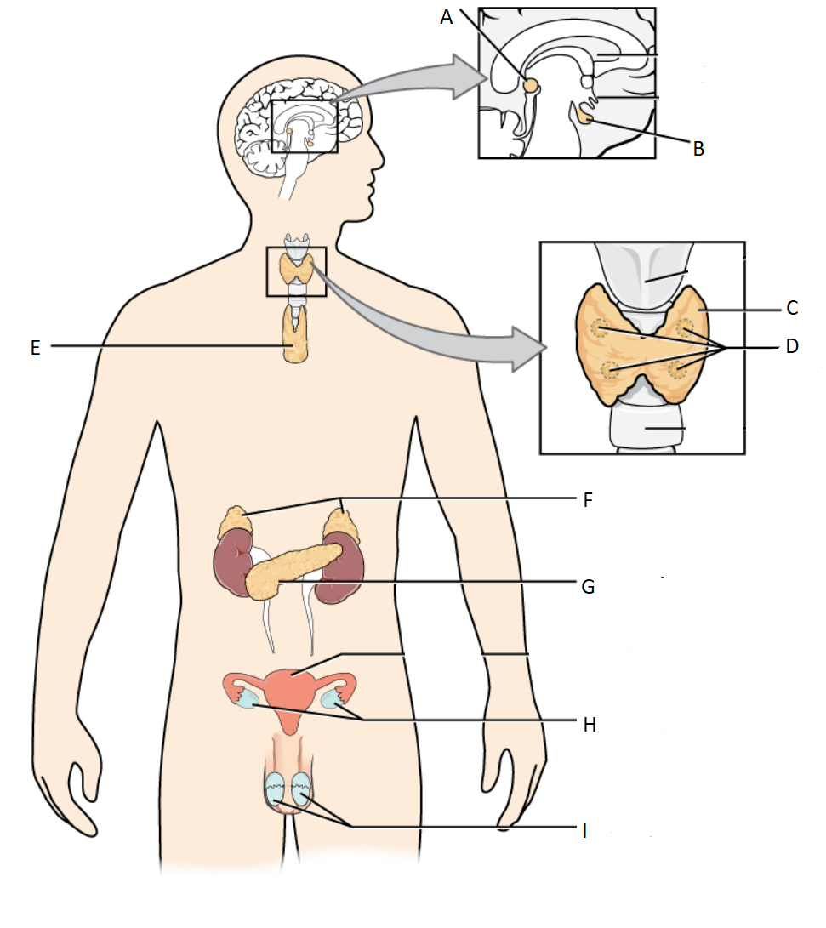

1. Name the endocrine organ and give an example of **one** hormone it produces. (6 marks)

|  |  |
| --- | --- |
| **Description** | **Mark** |
| C: Thyroid  Thyroxine/Calcitonin | 1  1 |
| H: Ovaries  Oestrogen/Progesterone | 1  1 |
| F: Adrenal  Cortisol/adrenalin/aldosterone | 1  1 |
| **Total** | **6** |

1. Complete the table below to identify the **target organ/s** and **effect** **on the body** of the following hormones. (6 marks)

|  |  |
| --- | --- |
| **Description** | **Mark** |
| Aldosterone  Target organ: Kidneys  Increases the amount of sodium reabsorbed into the bloodstream and increases the amount of potassium excreted in urine | 1  1 |
| Thyroid Stimulating Hormone  Target organ: Thyroid  Effect on the body: Stimulates the production of thyroxine | 1  1 |
| Prolactin  Target organ: breasts/milk ducts/mammary glands  Effect on the body: Causes the release of breast milk/promotes milk production | 1  1 |
| **Total** | **6** |

1. Describe **one** effect on the body for the overproduction of each of the following hormones. (3 marks)

|  |  |
| --- | --- |
| **Description** | **Mark** |
| Growth Hormone  Overproduction would result in the body/parts of the body growing bigger than usual | 1 |
| Parathyroid Hormone  Overproduction would lead to excess calcium removed from bones to the blood/decrease in bone strength | 1 |
| Cortisol  Overproduction would lead to heart stress due to constant increased heart rate/increase infections due to suppressed immune system | 1 |
| **Total** | **3** |

(d) Cortisol and glucagon are both hormones that work to increase the levels of glucose in the blood. However, they differ in their mode of action. Cortisol is a lipid soluble hormone and glucagon is a water-soluble hormone. In the table below contrast the mode of action of these two hormones. (4 marks)

|  |  |
| --- | --- |
| **Description** | **Mark** |
| Cortisol passes through the cell membrane | 1 |
| Glucagon binds to receptors on the membrane | 1 |
| Cortisol binds directly to the DNA | 1 |
| Glucagon has a secondary messenger | 1 |
| The effects of cortisol will last longer | 1 |
| The effect of glucagon will last for a much smaller amount of time | 1 |
| **Total** | **Any 4 (max)** |
| **A labelled diagram that illustrates any of the above points can be used in students’ answers** |  |

**Question 34 (13 marks)**

1. An elite swimmer measured the pH level of his blood prior to a race. It returned a reading 7.57pH. Immediately following the 50m freestyle event he measured his blood pH again, this time the result was 7.25pH.
   * 1. What caused the pH level of the blood to drop, following the race? (2 marks)

|  |  |
| --- | --- |
| **Description** | **Mark** |
| Increased cellular activity/metabolism/respiration/CO2 production/CO2 level in blood | 1 |
| Causes an increase in hydrogen ion concentration/higher acidity/carbonic acid/lactic acid | 1 |
| **Total** | **2** |

* + 1. The drop in pH was detected by receptors and caused a change in breathing rate.

Describe the events that occurred in the body to cause the change in breathing rate. (5 marks)

|  |  |
| --- | --- |
| **Description** | **Mark** |
| Detected by chemoreceptors | 1 |
| In the carotid/aortic bodies/in the medulla oblongata (central chemoreceptor) | 1 |
| Send nerve impulses/stimulates to the medulla/respiratory centre | 1 |
| Nerve impulses sent to diaphragm/respiratory muscles/intercostal muscles | 1 |
| Increased rate and depth of breathing | 1 |
| **Total** | **5** |

1. Some of the swimmers have been known to hyperventilate immediately prior to a big race. State what impact this will have on the breathing response and give a reason why it is not advised. (3 marks)

|  |  |
| --- | --- |
| **Description** | **Mark** |
| Hyperventilating removes more CO2 form the blood than usual | 1 |
| This will increase the amount of time a person can hold their breath for | 1 |
| Risk of drowning/ fainting due to low oxygen | 1 |
| **Total** | **3** |

1. Aside from increased breathing rate, what are **three** other physiological changes that occur in the body during and immediately after exercise to maintain blood pH as close to optimal? (3 marks)

|  |  |
| --- | --- |
| **Description** | **Mark** |
| **Any three of the following** | |
| Increased heart rate | 1-3 |
| Increased blood flow/vasodilation to muscles/reduced blood flow/vasoconstriction to organs |
| Release of adrenaline/noradrenaline to the blood stream |
| Increased stimulation of sympathetic nervous system |
| **Total** | **3** |

**Question 35 (10 marks)**

Many homeostatic mechanisms are regulated by the hypothalamus.

1. Describe the processes leading to the secretion of hormones from the anterior lobe into the bloodstream. (3 marks)

|  |  |
| --- | --- |
| **Description** | **Mark** |
| **Any three of the following** | |
| Hypothalamus detects a change in blood hormone concentrations | 1-3 |
| Anterior lobe is stimulated by releasing factors (delivered via network of blood vessels) |
| Anterior pituitary produces and secretes hormone |
|  |
| **Total** | **3** |

1. Explain why the posterior lobe of the pituitary is not considered to be a true endocrine gland. (2 marks)

|  |  |
| --- | --- |
| **Description** | **Mark** |
| Posterior pituitary does not manufacture any hormones | 1 |
| It releases hormones made in the hypothalamus to the blood stream | 1 |
| **Total** | **2** |

1. Cortisol production is indirectly dependent on the pituitary gland. If cortisol levels in the blood stream are too low how does the pituitary respond to increase cortisol production. (2 marks)

|  |  |
| --- | --- |
| **Description** | **Mark** |
| The low cortisol levels are detected and the anterior pituitary releases/secretes ACTH (adrenocorticotrophic hormone) | 1 |
| ACTH binds to receptors in the adrenal cortex to stimulate the production of cortisol | 1 |
| **Total** | **2** |

1. Name two other pairs of hormones where the release of a hormone from one endocrine organ triggers the release of a hormone from a different endocrine organ.

(2 marks)

|  |  |
| --- | --- |
| **Description** | **Mark** |
| Thyroid Stimulating hormone/TSH à Thyroxine | 1 |
| Luteinising Hormone/LHà Testosterone (males) | 1 |
| **Total** | **2** |

**Question 36 (13 marks)**

The flu season in 2019 was one of the worst in history with over 200000 people diagnosed with the flu and 430 deaths in Australia due to flu complications. Immunisation of the flu is recommended yearly and the most common type is a mixed vaccine that contains three strains of live-attenuated pathogen.

1. What type of pathogen causes the flu and how is it transmitted from person to person? (2 marks)

|  |  |
| --- | --- |
| **Description** | **Mark** |
| Virus | 1 |
| (Person to person) through droplets in coughing/sneezing | 1 |
| Contact (direct or indirect) | 1 |
| **Total** | **2** |

1. Outline steps the body goes through when administered with the flu vaccine so they will be protected from the infection over the flu season. (5 marks)

|  |  |
| --- | --- |
| **Description** | **Any three of the following** |
| **Any five of the following** | |
| The pathogen in the vaccine in consumed by macrophage | 1-5 |
| B-cells receive information become sensitised |
| Enlarged and divide to create plasma cells |
| B-cells/plasma use this information to create correct antibodies |
| Memory cells are formed which leads to secondary response/faster response/less symptoms |
| **Total** | **5** |

1. Aside from receiving the flu vaccine, describe **three** things people can do to reduce their chance of catching this infection. (3 marks)

|  |  |
| --- | --- |
| **Description** | **Mark** |
| **Any three of the following** | |
| Stay (1 metre) away from anyone who is coughing or sneezing | 1-3 |
| Avoid touching your face/nose/mouth with your hands |
| Wash your hands regularly |
| Do not kiss/hug anyone who is sick |
| Sanitise surfaces |  |
| Wear a facemask |  |
| **Total** | **3** |

1. State two reasons why people need to receive a new flu vaccine every year.

(2 marks)

|  |  |
| --- | --- |
| **Description** | **Mark** |
| Flu mutates regularly/many different strains exist and are common at different times | 1 |
| Protection from flu strains one year won’t guarantee protection the next year/the body’s immunity to the flu decreases over time | 1 |
| **Total** | **2** |

1. If a person becomes infected with the flu, what type of medication could they take to reduce the severity of symptoms?

(1 mark)

|  |  |
| --- | --- |
| **Description** | **Mark** |
| Antivirals/analgesics | 1 |
| **Total** | **1** |

**Question 37 (13 marks)**

Cerebrospinal fluid (CSF) is a clear fluid that surrounds the brain and spinal cord. It contains mostly water, glucose, urea and some salts. One function of the CSF is to act as a shock absorber to protect the brain from any physical or mechanical damage.

1. In addition to the function of the CSF in protecting the brain and spinal cord, name **two** other functions of this fluid. (2 marks)

|  |  |
| --- | --- |
| **Description** | **Mark** |
| **Any two of the following** | |
| Supports the brain/the brain is suspended in the fluid | 1-2 |
| Transport of nutrients (and removal of wastes) |
| Helps to maintain constant temperature of the brain |
| **Total** | **2** |

1. Name two other structures that protect the brain from damage. (2 marks)

|  |  |
| --- | --- |
| **Description** | **Mark** |
| The skull/bone in the skull | 1 |
| The meninges | 1 |
| **Total** | **2** |

1. Daryl was an avid motorcyclist who lived in the far north of Western Australia and would sometimes forgo protective equipment, including his helmet, due to the extreme temperatures. One day he was riding his motorbike, fell and hit his head causing damage to his cerebellum.

Suggest **two** symptoms Daryl could have suffered after his accident that would have been caused by damage to the cerebellum. (2 marks)

|  |  |
| --- | --- |
| **Description** | **Mark** |
| Problems with balance | 1-2 |
| Problems with coordination of voluntary movement |
| Problems with posture |
| Specific example including writing/using a computer/playing an instrument/ driving a car |
| **Any 2 Total** | **2** |

1. When Daryl fell from his motorcycle he was riding with his friend Barry. Barry saw the accident and immediately stopped riding and ran to his friend to help. Daryl was trapped under his motorcycle in a ditch by the side of the road and despite Daryl and the motorcycle both being heavier than Barry he was able to pull Daryl from under the motorcycle and out of the ditch to perform CPR.

Describe the nervous signals that were sent between Barry’s body and brain from the time he witnessed the accident to commencing CPR on his friend.

(5 marks)

|  |  |
| --- | --- |
| **Description** | **Mark** |
| Receptor (must include location eg eye) | 1 |
| Sensory neuron carries impulse towards CNS/away from receptor | 1 |
| Cerebrum/cerebral cortex will process impulse | 1 |
| Motor neuron carries impulse away from CNS/towards effector | 1 |
| Effector – skeletal muscles/voluntary muscles | 1 |
| **Total** | **5** |

1. In hospital doctors suggest using cell replacement therapy to treat Daryl’s damaged cerebellum.

What is cell replacement therapy? What is **one** other disorder that has been treated (at the clinical trial stage) using this method?

(2 marks)

|  |  |
| --- | --- |
| **Description** | **Mark** |
| Cell replacement therapy is the replacement of damaged cells with healthy ones | 1 |
| Parkinson’s disease | 1 |
| Alzheimer’s | 1 |
| **Total** | **2** |

**Question 38 (8 marks)**

An archaeologist, Freya is conducting a dig on an historical site in the middle of the Great Sandy Desert. Despite the extreme heat her core body temperature remains the same due to the physiological responses of her body.

1. Name **two** physiological changes the body makes to increase heat loss. In your answer describe how each change promotes heat loss. (4 marks)

|  |  |
| --- | --- |
| **Description** | **Mark** |
| Sweating  Heat is lost as the water evaporates from the skin | 1  1 |
| Vasodilation (to the skin)  Blood travels closer to the surface of the skin and heat is lost by convection/radiation/conduction | 1  1 |
| **Total** | **4** |

1. Describe **three** behavioural changes Freya can make to stay as cool as possible as she works in the sun. (3 marks)

|  |  |
| --- | --- |
| **Description** | **Mark** |
| **Any three of the following** | |
| Wear a hat/ loose clothing/ put up a shade to protect from the sun | 1-3 |
| Fan herself as she works/ put a fan on |
| Cover herself in wet towels/ splash water on her face/ wet her hair |
| Have cold fluids/ice to drink/eat |
| Remove clothing |  |
| **Total** | **3** |

1. Name **one** other homeostatic control system that would have to be monitored closely to maintain health in a desert environment.

(1 mark)

|  |  |
| --- | --- |
| **Description** | **Mark** |
| Body fluids | 1 |
| **Total** | **1** |

**Section Three: Extended answer 20% (40 Marks)**

This section contains **three** questions. You must answer **two (2)** questions. Write your answers on the pages following Question 41.

Supplementary pages for planning/continuing your answers to a question are provided at the end of this Question/Answer booklet. If you use these pages to continue an answer, indicate at the original answer where the answer is continued, i.e. give the page number.

Suggested working time: 50 minutes.

Answer any **two** questions from Questions 39 to 41.

Indicate the questions you will answer by ticking the box next to the question. Write your answers on pages that follow.

**Question 39 (20 marks)**

1. Describe how a nerve impulse is propagated along an unmyelinated nerve fibre. Explain how a nerve impulse being propagated along a myelinated nerve fibre differs to an unmyelinated nerve fibre?

(10 marks)

|  |  |
| --- | --- |
| **Description** | **Mark** |
| **Any 8 of the following** | |
| Stimulation of cell occurs allowing sodium ions into the cell | **1-8** |
| Reaches threshold of –55mV/change of 15mV |
| Cell membrane becomes more permeable to sodium ions/ more sodium ions rush in |
| Inside the cell becomes more positive relative to the outside/ rapid depolarisation occurs/ Action potential |
| Sodium gates close and potassium gates open |
| Potassium ions diffuse out the cell |
| Inside of the cell becomes more negative relative to the outside/neuron repolarises |
| Hyperpolarisation occurs (as potassium gates close) |
| Sodium-Potassium pump activates |
| Transports sodium ions out of the cell and potassium into the cell |
| Restores original ion concentration/resting membrane potential |
|  |  |
| **Following two marks** | |
| Faster along myelinated | **1** |
| Jumps from Node (of Ranvier) to Node (of Ranvier) in myelinated/saltatory conduction | **1** |
| **Total** | **10** |

1. Hepatitis B is a virus that can cause severe liver problems in those infected. Hepatitis B can be prevented with a vaccine that has been produced using recombinant DNA technology.

Describe the process that produces the Hepatitis B vaccine by recombinant DNA technology.

(10 marks)

|  |  |
| --- | --- |
| **Description** | **Mark** |
| **Any 10 of the following** | |
| The gene/segment of DNA is isolated | **1-10** |
| Cut at recognition sites |
| By restriction enzymes |
| Enzyme cuts the DNA at either end of the gene |
| Producing a staggered cut |
| Unpaired nucleotides overhang the ends/produce a sticky end |
| Plasmid is isolated from bacterial cell |
| The isolated gene and the plasmid are joined together |
| By DNA ligase |
| Gene and plasmid inserted into bacterial cell/treated |
| The bacterial cell is cloned/divides |
| Large amounts of the vaccine produced |
| Purify the samples to isolate the vaccine |
| Package the hormone/vaccine in a form that humans could consume |
| **Total** | **10** |

**Question 40 (20 marks)**

A person goes out for a celebratory breakfast and ingests orange juice, pancakes with syrup and hot chocolate. The high sugar content of this meal causes an immediate spike in blood sugar levels but are rapidly brought back down to a normal level.

* 1. Describe the homeostatic mechanism that causes a decrease in high blood sugar levels in the minutes after the meal. (10 marks)

|  |  |
| --- | --- |
| **Description** | **Mark** |
| Chemo/glucoreceptors in the Beta cells in the Islets of Langerhans/ pancreas | **1** |
| detect an increase in blood sugar | **1** |
| Beta cells in the Islets of Langerhans secrete insulin | **1** |
| Insulin travels in the blood stream all around the body | **1** |
| Insulin causes blood glucose to enter cells | **1** |
| Insulin causes blood glucose to be converted to glycogen | **1** |
| This is called glycogenesis | **1** |
| Glycogen is stored in liver and/or skeletal muscles | **1** |
| Insulin causes blood glucose to be stored as fat | **1** |
| Insulin promotes protein synthesis which uses blood glucose | **1** |
| **Total** | **10** |

(b) If this person suffered with undiagnosed type I diabetes, describe symptoms that would occur as the body attempts to remove excess sugar from the body.

(4 marks)

|  |  |
| --- | --- |
| **Description** | **Mark** |
| **Any TWO symptoms with correct description** | |
| **Symptoms and description** | |
| Thirst  Increase thirst to try to dilute the sugar int the blood/remove from body | **1**  **1** |
| Increased frequency of urination  Excess sugar in the blood is removed through the urine | **1**  **1** |
| Tiredness/lethargy  Sugar in the blood cannot be used by cells for energy | **1**  **1** |
| Irritability  Due to inability to use energy to focus/think/moderate emotions | **1**  **1** |
| **Total** | **4** |

1. Describe the differences between Type I and Type II diabetes, with regards to their cause, the age of onset and their treatment.

|  |  |
| --- | --- |
| **Description** | **Mark** |
| **One mark each for cause, symptoms and treatment for type I and type II** | |
| **Type I diabetes** | |
| Cause  Destruction of Beta cells  Autoimmune/ compromised immune system following illness | **1** |
| Age of onset  Young/In childhood/In adolescence | **1** |
| Treatment  Insulin injections/insulin pump | **1** |
| **Type II diabetes** | |
| Cause  Lifestyle factors/high sugar/calorie/fat diet/obesity/some genetic factors | **1** |
| Age of onset  (Although some diagnosed in their late teens) Late adulthood/middle age and older | **1** |
| Treatment  Low fat/sugar diet/exercise/ weight loss/insulin tablets | **1** |
| **Total** | **6** |

(6 marks)

**Question 41 (20 marks)**

Antibiotics are medications that are used to treat bacterial infections but are not effective against viral pathogens.

1. Outline the reasons why antibiotics are ineffective against viral infections.

(3 marks)

|  |  |
| --- | --- |
| **Description** | **Mark** |
| Antibiotics work on the cell structure/block translation during protein synthesis/cell wall | **1** |
| Viruses have no cell structure/ invade body cells to make more viruses | **1** |
| Antibiotic cells can’t distinguish normal body cells from infected cells | **1** |
| **Total** | **3** |

1. What is an antibiotic? In your answer name the two different types of antibiotic medications and describe how they work to combat a bacterial infection.

(7 marks)

|  |  |
| --- | --- |
| **Description** | **Mark** |
| What is an antibiotic | |
| A chemical that fights the infection of micro-organisms/bacteria | 1 |
| Types of antibiotics | |
| Bactericidal | 1 |
| Bacteriostatic | 1 |
| How they work | |
| Bactericidal antibiotics change the structure of the bacterial cell wall/cell membrane | 1 |
| Bactericidal antibiotics disrupt the action of essential enzymes | 1 |
| Bacteriostatic antibiotics stop bacteria from reproducing | 1 |
| Bacteriostatic antibiotics disrupt the protein synthesis of bacteria | 1 |
| **Total** | **7** |

1. Vaccines can be used to provide immunity to a disease without ever becoming infected. Aside from live-attenuated vaccines name two different types of vaccines and describe their features.

(4 marks)

|  |  |
| --- | --- |
| **Description** | **Mark** |
| Any **two** vaccine types with correct description | |
| Vaccine type | |
| Dead microorganisms | 1 |
| Contain the whole dead organism/immunity produced can be short lived | 1 |
| Vaccine type | |
| Sub-unit | 1 |
| Fragment of the organism is used to produce an immune response | 1 |
| Vaccine type | |
| Toxoids | 1 |
| Toxins produced by bacteria are inactivated and injected to provoke an immune response | 1 |
| **Any two vaccine types Total** | **4** |

Rani was vaccinated against measles when she was an infant but her friend Martha was not. They both went on holiday and were contacted later about a measles outbreak on the plane on the way back to Perth. Martha became ill and contracted measles whereas Rani did not.

1. Describe the difference between Rani and Martha’s immune response to the measles pathogen when they were exposed on the plane.

(6 marks)

|  |  |
| --- | --- |
| **Description** | **Mark** |
| **Rani** | |
| Rani’s response was a secondary response | 1 |
| Rani already had memory cells against measles | 1 |
| Memory cells produced antibodies very quickly | 1 |
| **Martha** | |
| Martha’s response was a primary response | 1 |
| Her B-cells ingested the antigen and went through an immune response | 1 |
| This immune response took time which is why Martha got sick/ new memory cells were formed | 1 |
| **Total** | **6** |

**ACKNOWLEDGEMENTS**

**Question 10** Adapted from [*File:Anatomy and physiology of animals A reflex arc az.jpg"*](https://commons.wikimedia.org/w/index.php?curid=12454600)*by*[*MrArifnajafov*](https://commons.wikimedia.org/wiki/User:MrArifnajafov)retrieved 9 October, 2019 from <https://search.creativecommons.org/photos/8a737b31-ed97-492c-8b68-75a5dd4a433f>

**Question 13** Adapted from image retrieved 24 February, 2020 from <https://en.wikipedia.org/wiki/Pituitary_gland#/media/File:1806_The_Hypothalamus-Pituitary_Complex.jpg>

**Question 17** Neuromuscular junction[image] retrieved 16 January, 2020 from <https://en.wikipedia.org/wiki/Neuromuscular_junction>

**Question 32** Adapted from brain[image] retrieved 13 October, 2019 from <https://commons.wikimedia.org/w/index.php?title=Special:Search&limit=20&offset=20&profile=default&search=brain+diagram&advancedSearch-current=%7B%7D&ns0=1&ns6=1&ns12=1&ns14=1&ns100=1&ns106=1&searchToken=5t1ghl6kj98mxf8r0brdfn6vr#%2Fmedia%2FFile%3ABrain_bulbar_region_as.svg>

**Question 33** Adapted from endocrine system [image] retrieved 11 March, 2019 from: <https://sco.wikipedia.org/wiki/File:1801_The_Endocrine_System.jpg>